TM1320
REVERSE ENGINEERING OF A CHEESE GRATER

BY

OGHENETEGA PROPSER EDAFIENENE
20205555

&

KINGSLEY EZENWA IZIMA
20201162

Table of Contents
Summary: 3
Objective: 3
Analysis: 3
Appendix A 5
SHOP DRAWING OF ALL COMPONENTS 5
Appendix B 14
ASSEMBLY DRAWING WITH BILL OF MATERIALS 14
Appendix C 16
EXPLODED ASSEMBLY DRAWING WITH BILL OF MATERIALS 16
Appendix D 18
SCREEN CAPTURE OF PARTS AND ASSEMBLY 18
Appendix E 27
HAND SKETCHES WITH MEASUREMENT 27

Summary:
This report presents a reverse engineering study of a plastic kitchen cheese grater. The process was carefully structured and divided into several key stages: disassembly, parts measurement and sketching, 3D modeling using SolidWorks, creation of detailed engineering drawings, and final product assembly with an accompanying bill of materials (BOM).

Objective:
The purpose of this report is to develop familiarity with the disassembly and reconstruction of a plastic cheese grater with the aim of gaining a comprehensive understanding of its design features, component interactions, and underlying manufacturing processes.

Analysis:
The reverse engineering process began with the disassembly of the cheese consisting of eight distinct parts: the handle, wheel axle, handle dowel, cheese holder, connecting rod, grater body, grater cap, and grater. This was carried out carefully, using a flat-head screwdriver to pry open plastic clips. It appeared this grater was intended for single-use assembly, as there was difficulty in separating components without breaking and chipping off important parts. This made it impossible to fully reassemble the grater after disassembly. As a result, photographic documentation had to be used for easy reference during assembly.
Once disassembled, precise measurements of each part were taken to ensure accurate modeling and consistency in assembly. Several challenges arose during the dimensioning and modeling phases. The most notable being obtaining accurate internal measurements. A vernier caliper was used to measure both the internal and external dimensions of each part. However, due to the enclosed design of the product, as well as small features, several internal features were inaccessible and had to be inferred, while others were too small to measure accurately. To minimize measurement and human error, multiple measurements were taken and averaged, thus improving the accuracy of the model.
The SolidWorks’ modeling phase was the most time-consuming and technically demanding aspect of the project due to the intricate features of each component. The approach began with establishing the core geometry of each part, followed by the integration of complex features such as angled surfaces, surface details, and functional cuts. Techniques like revolve, loft, sweep, shell, extruded cuts, mirroring, and circular patterns were used extensively across various components to meet design requirements. Reference planes were offset for off-axis features, while tangent planes were used for cylindrical bodies. The grater body and cheese holder required more complex operations involving patterned extrusions, swept profiles, and thin features to replicate fine details such as grating teeth and slanted holes. Countersinks, shelling, fillets, and asymmetric lofts helped simulate real-world design. These advanced modeling strategies were crucial for achieving a high level of accuracy and realism.
The assembly process proved to be the easiest phase, although minor dimensional adjustments were required to ensure proper fit between parts. Several constraints were applied to assembly, including gear mates to synchronize the rotation of the handle and grater, angle limits to restrict the movement of the cheese holder, and advanced width mates to center components within other profiles. The result was successful, with the completed model assembling as intended, showing movement of the handle as well as the cheese holder.

Appendix A

SHOP DRAWING OF ALL COMPONENTS
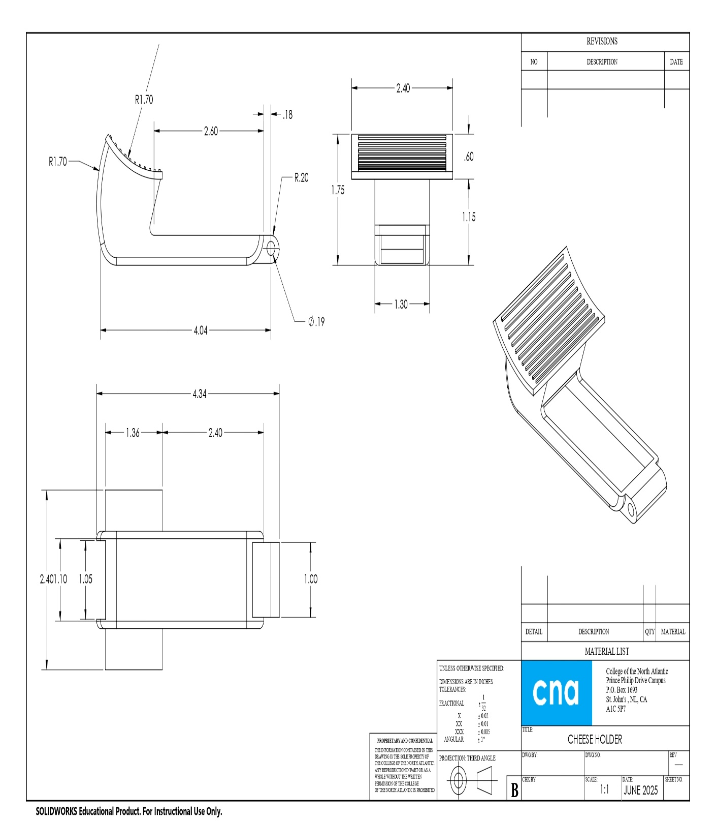
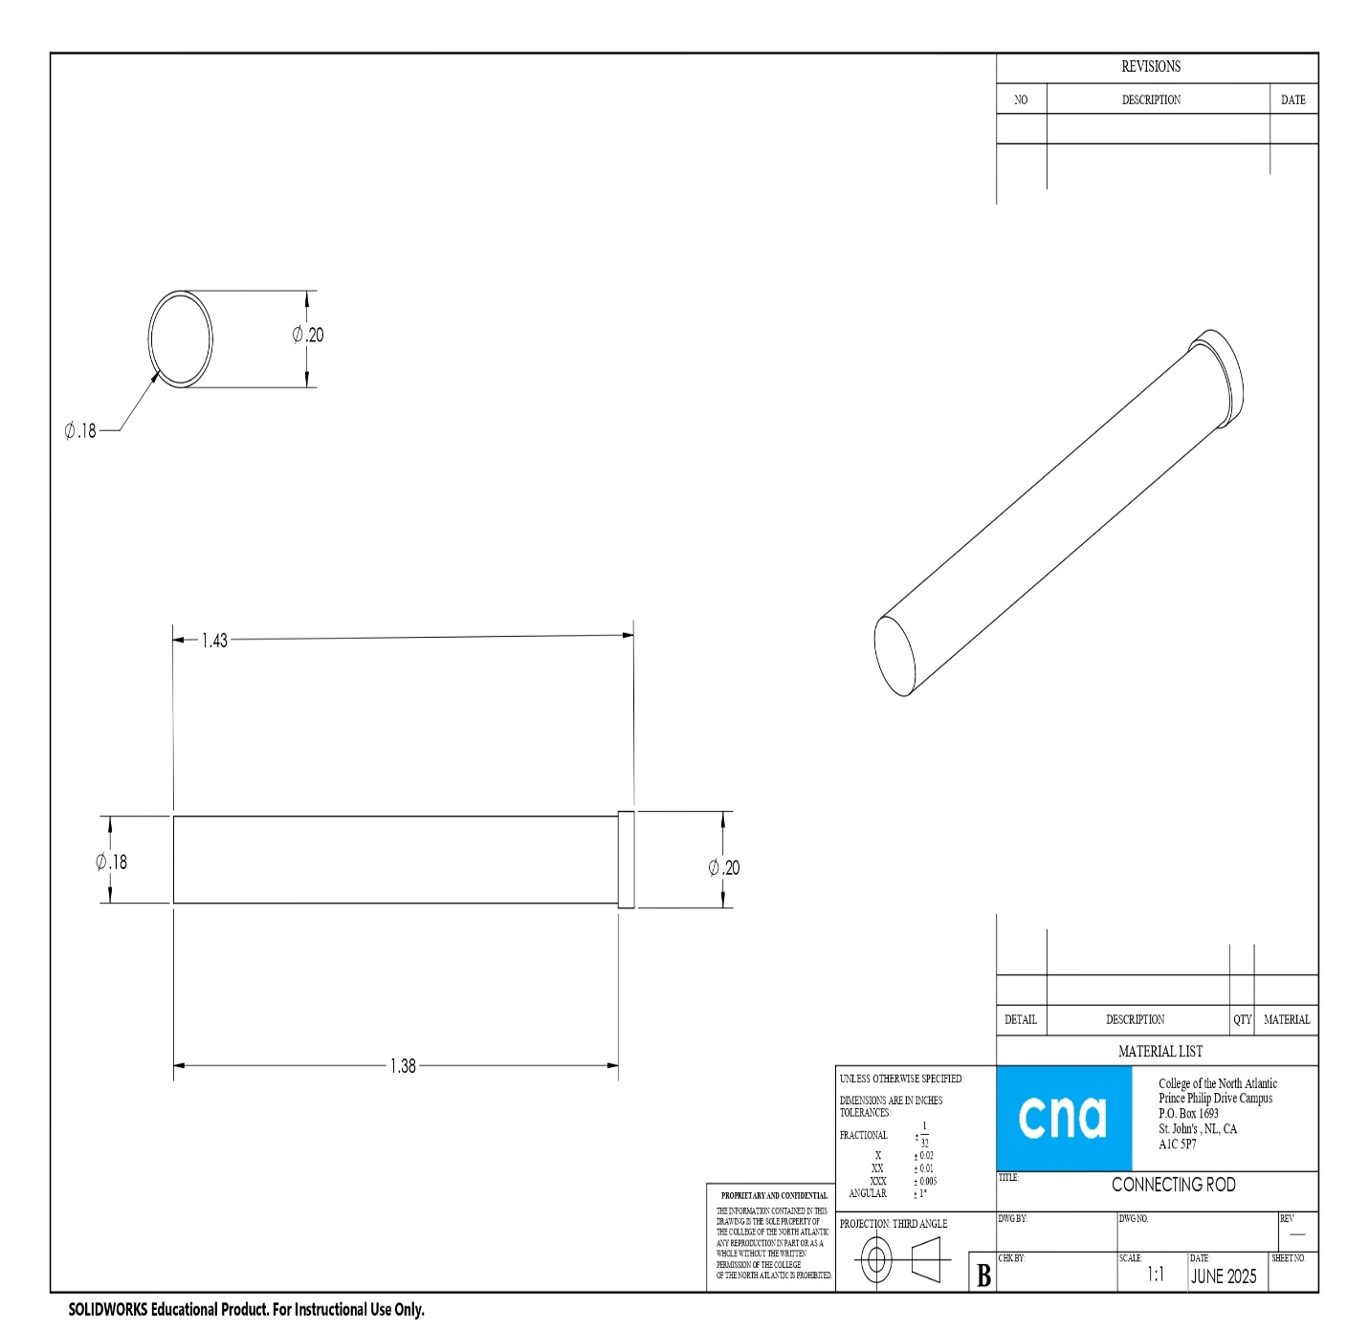
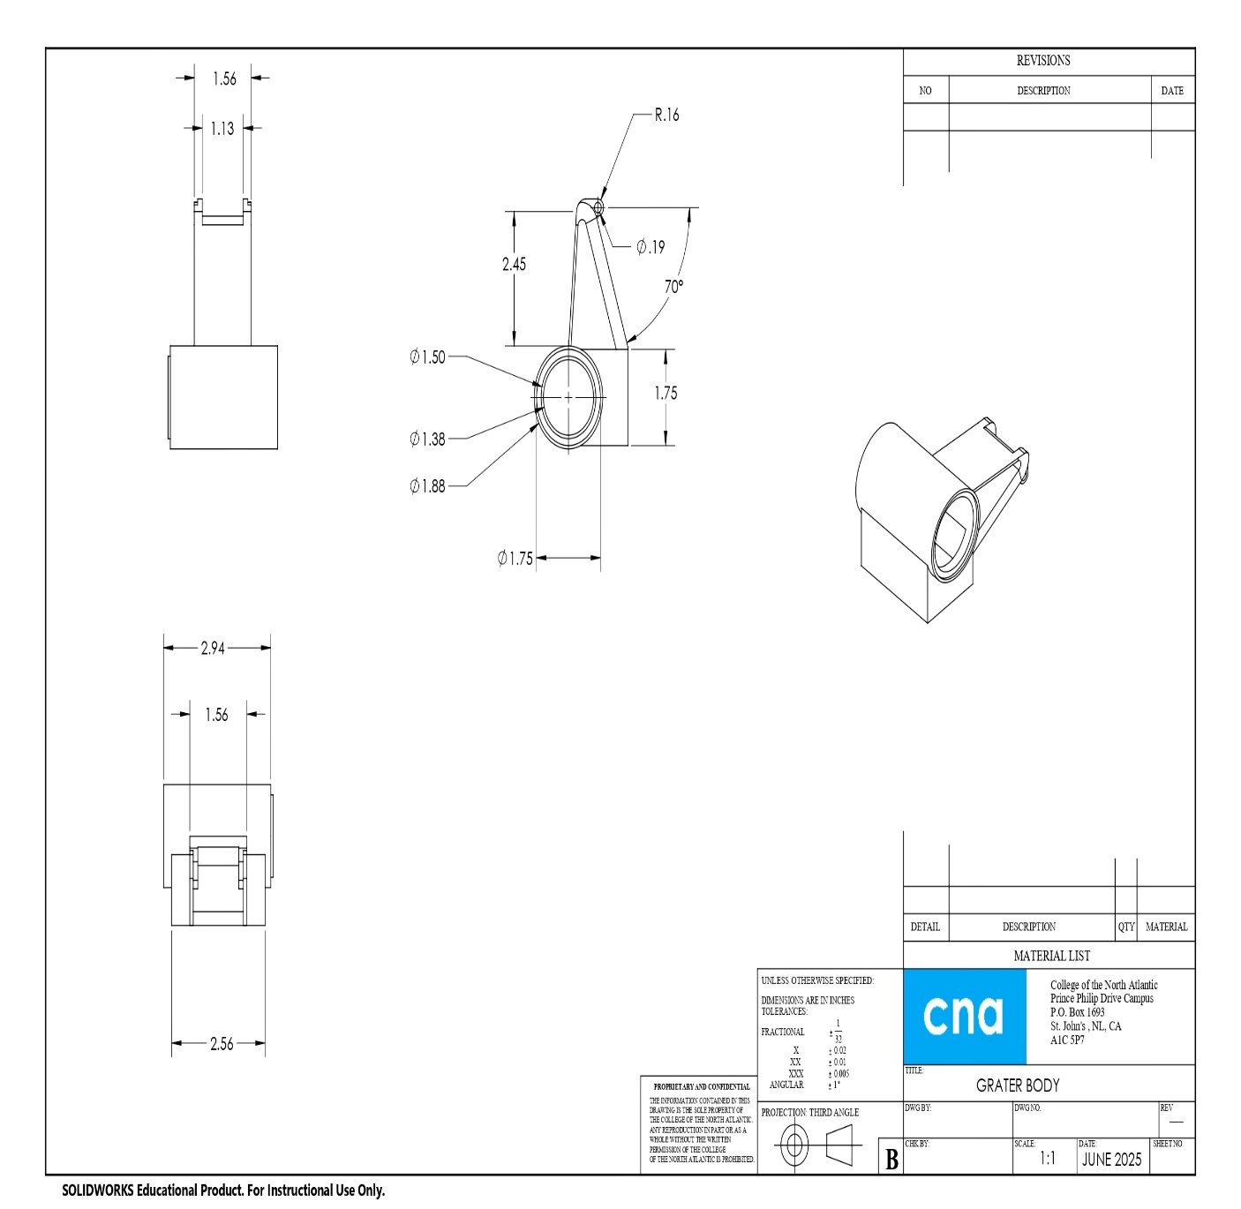
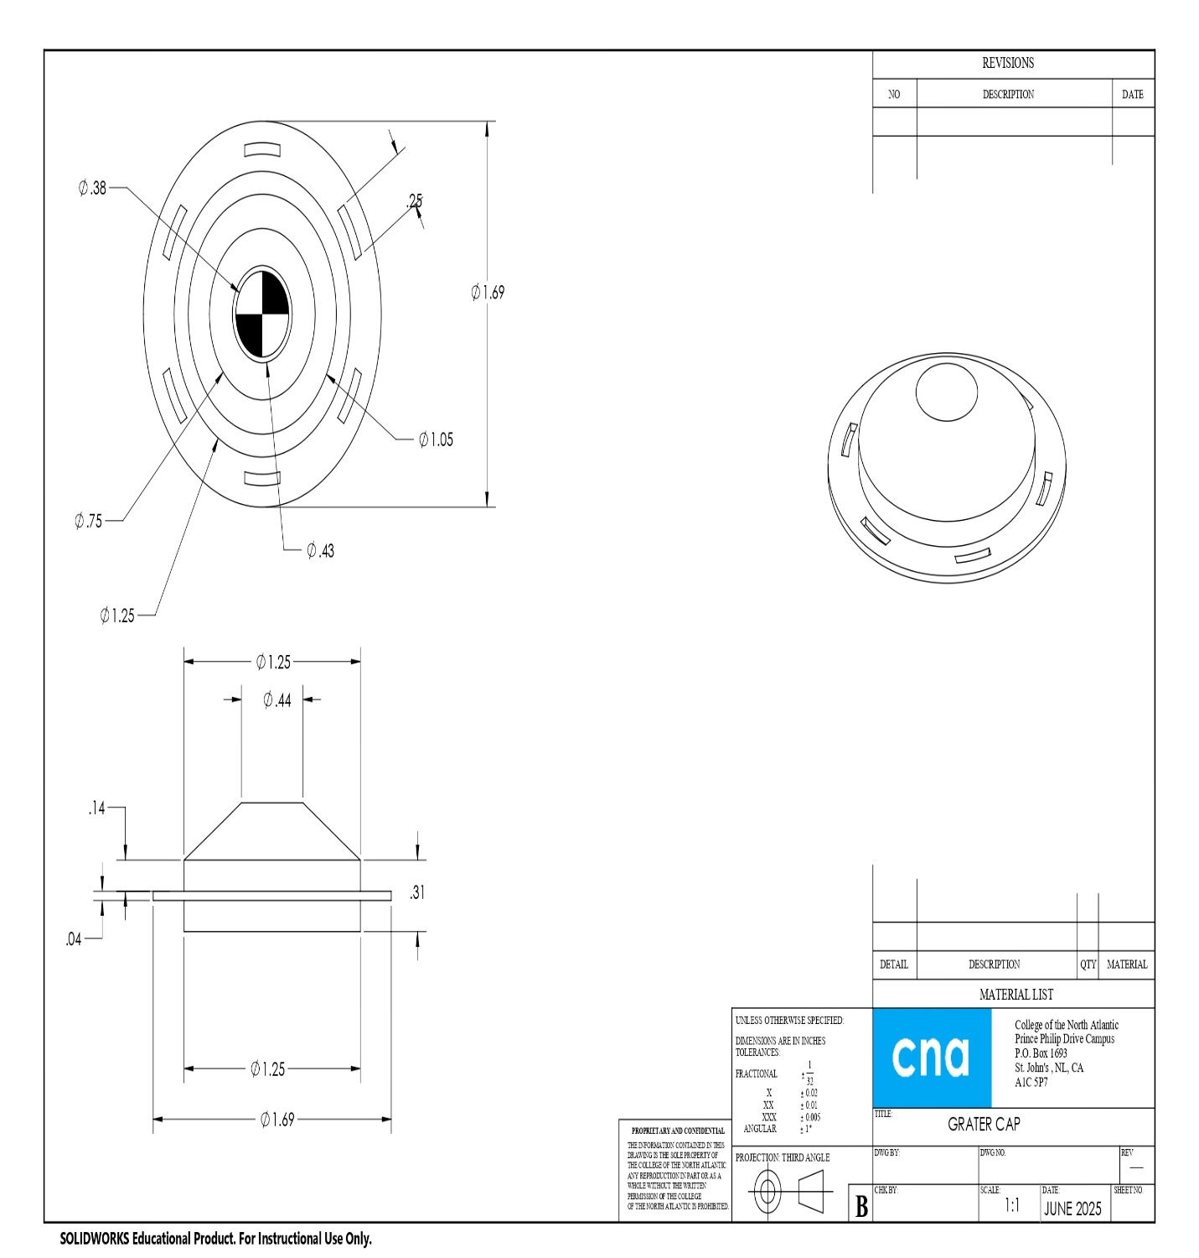
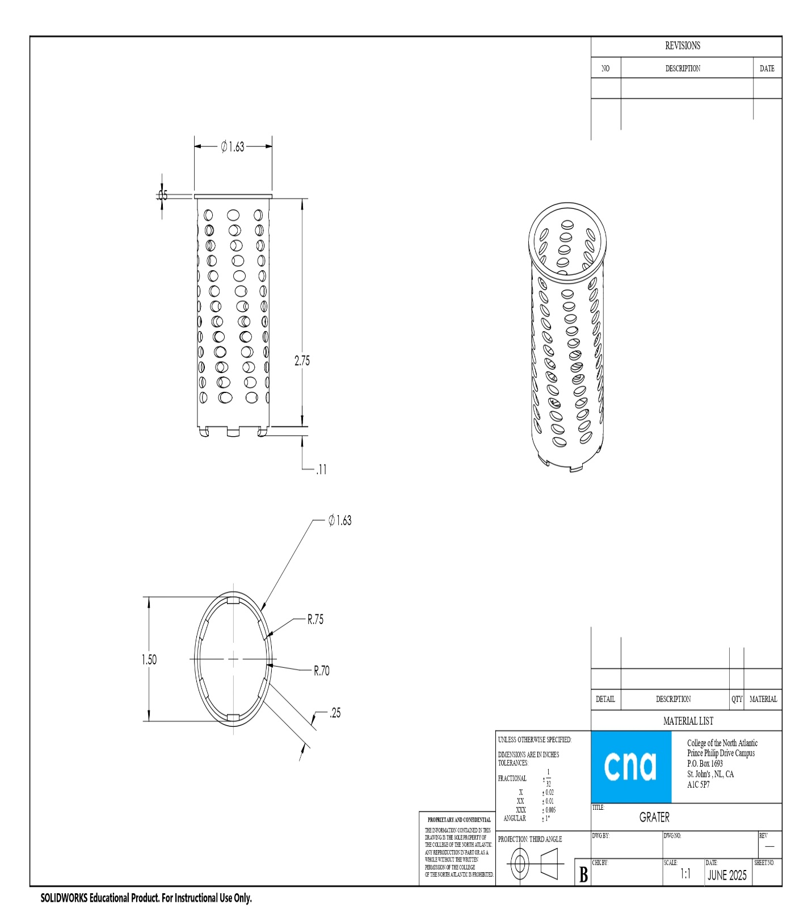
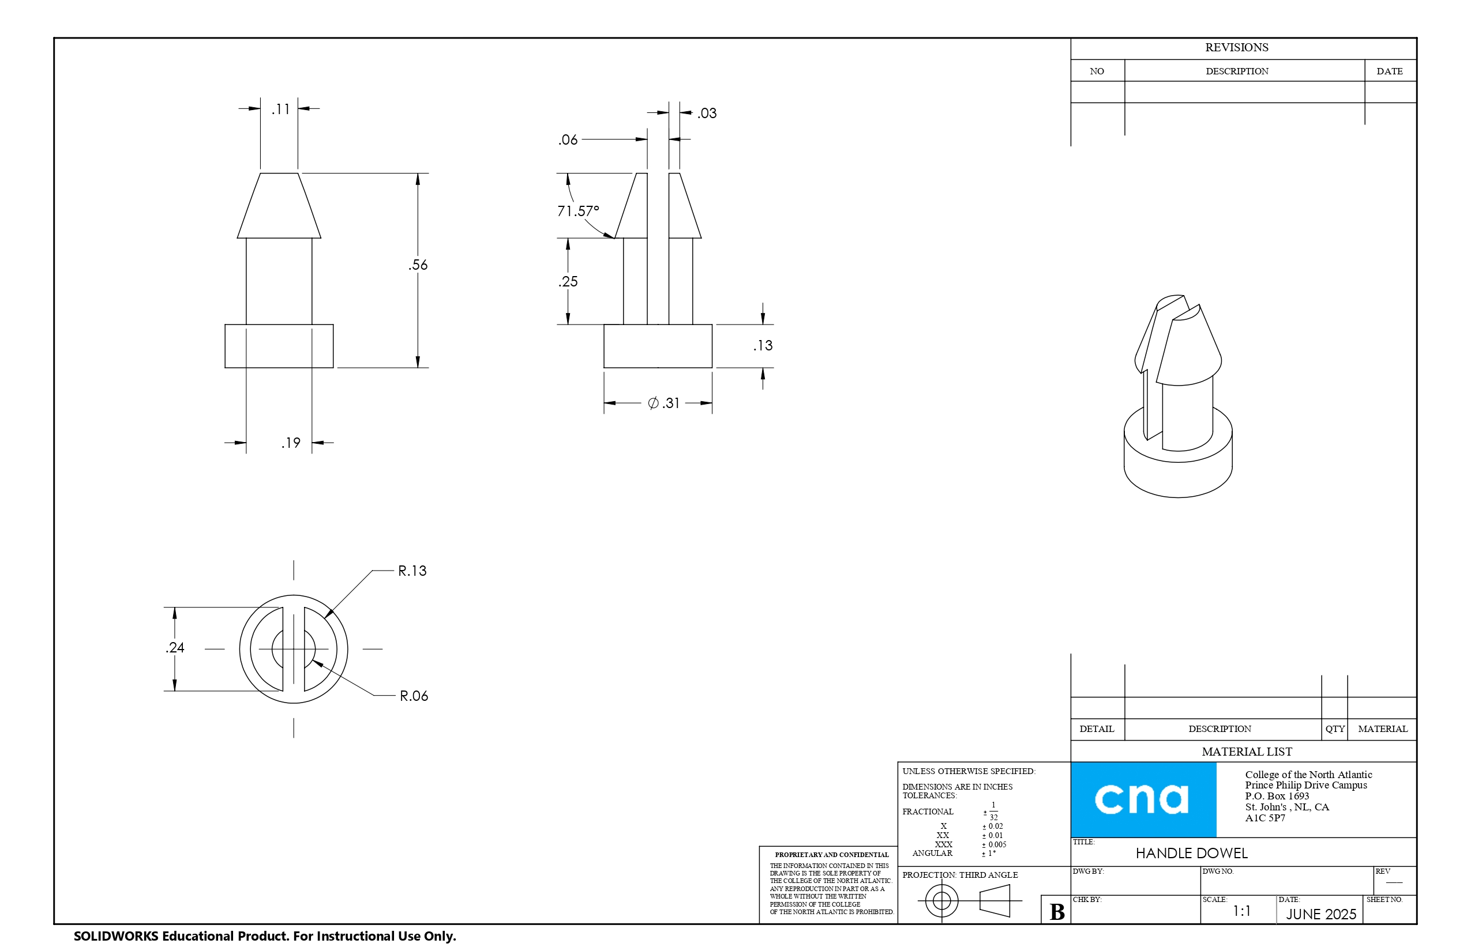
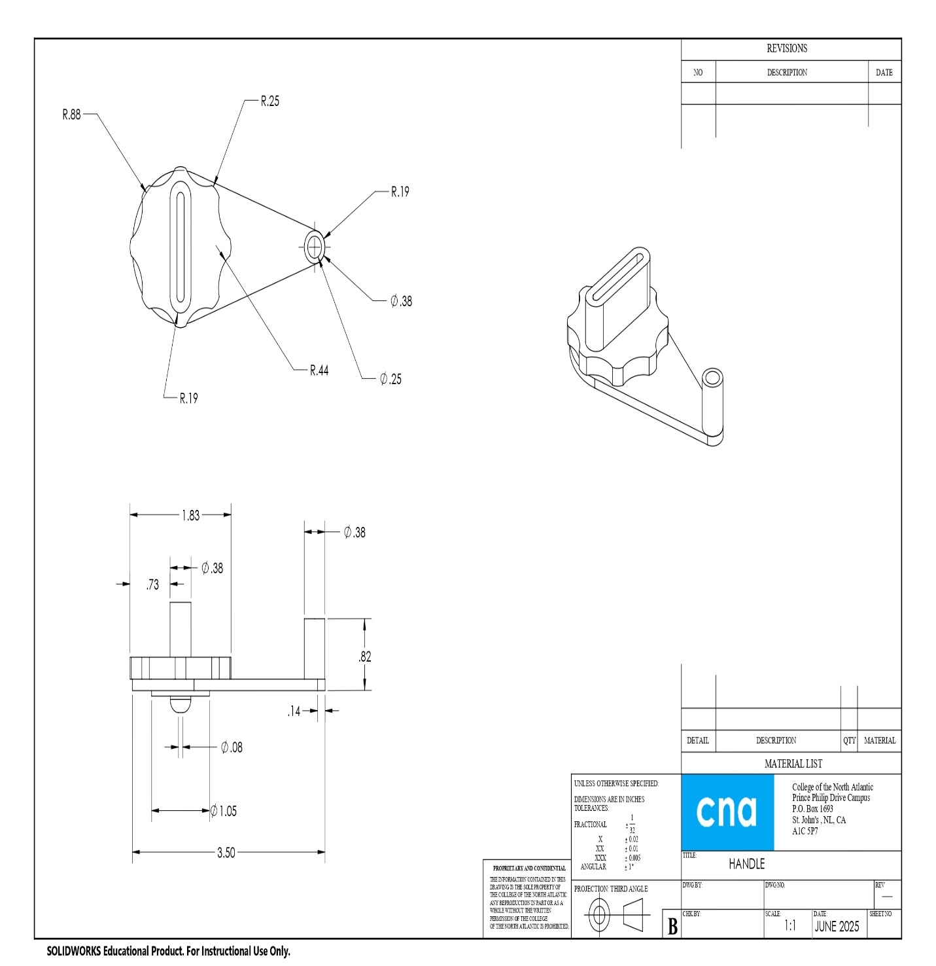
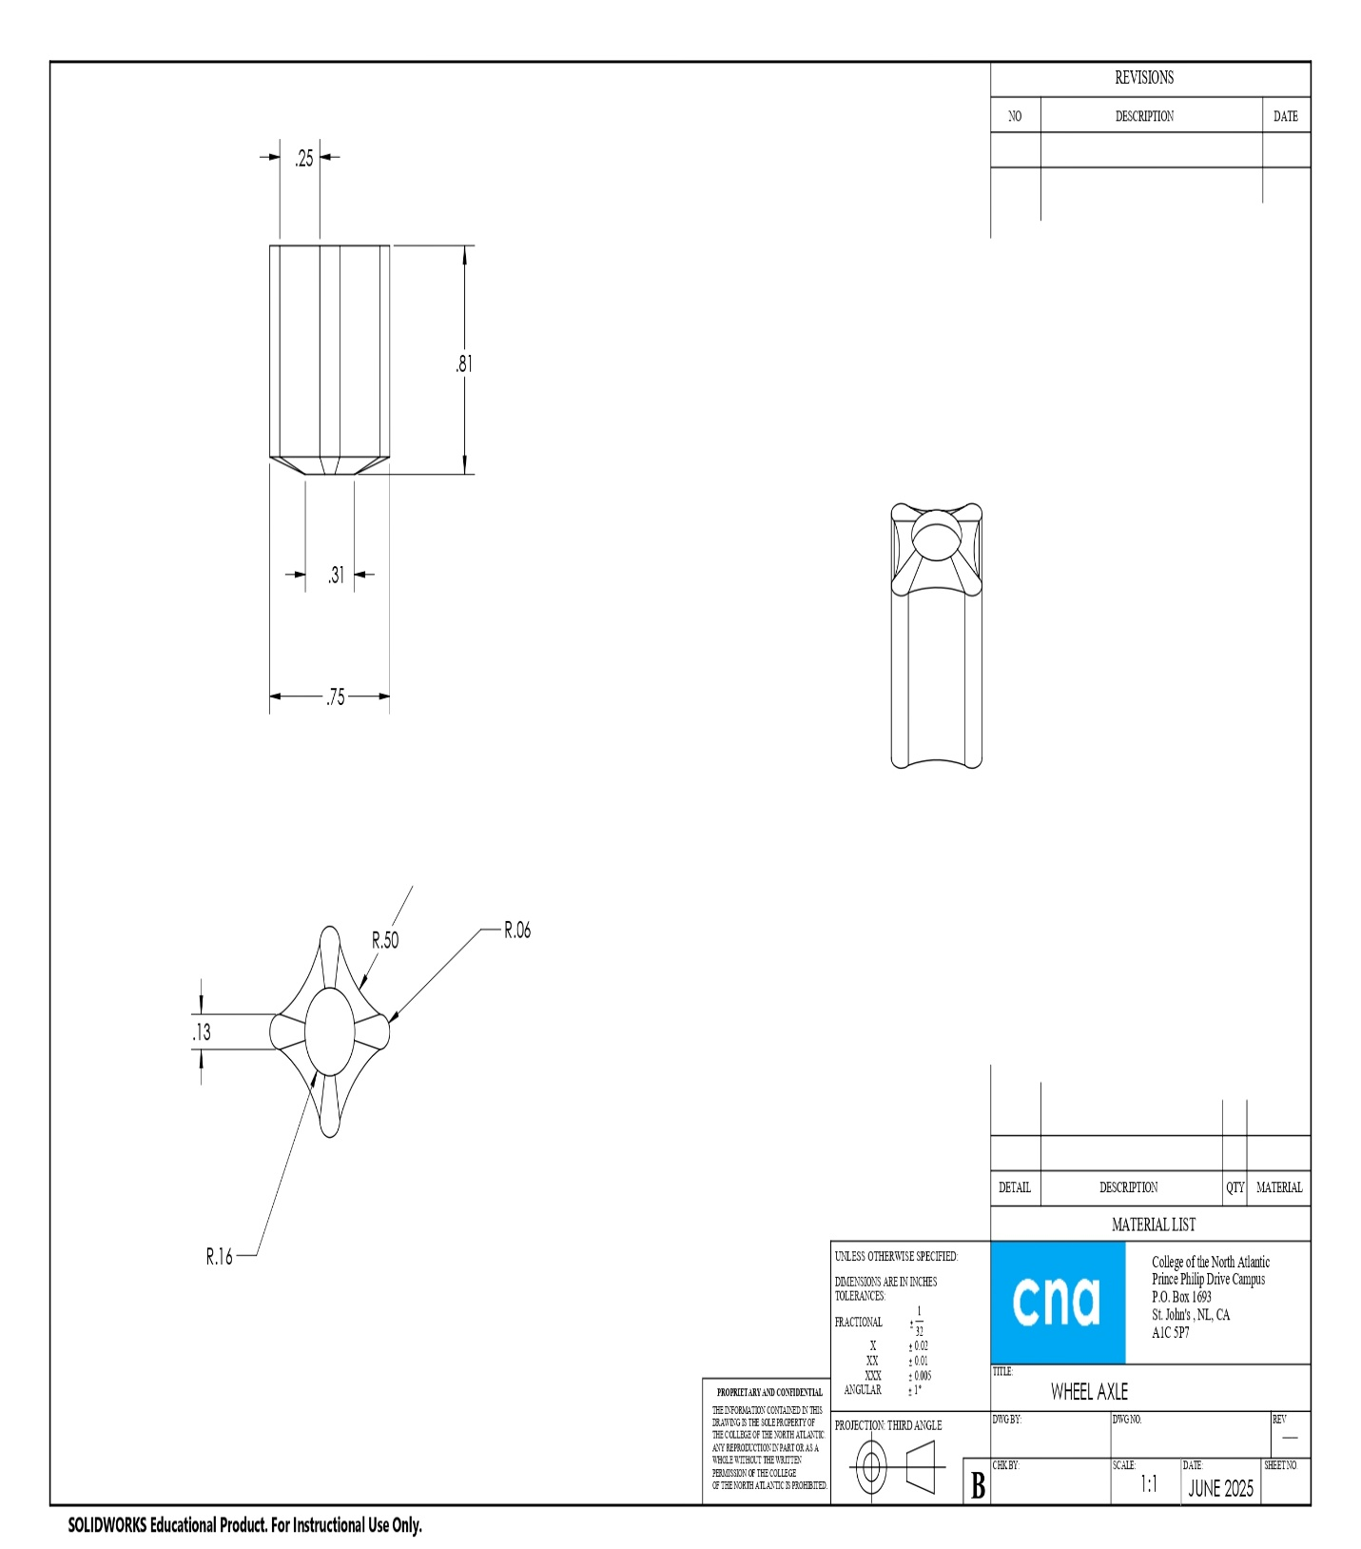

Appendix B

ASSEMBLY DRAWING WITH BILL OF MATERIALS
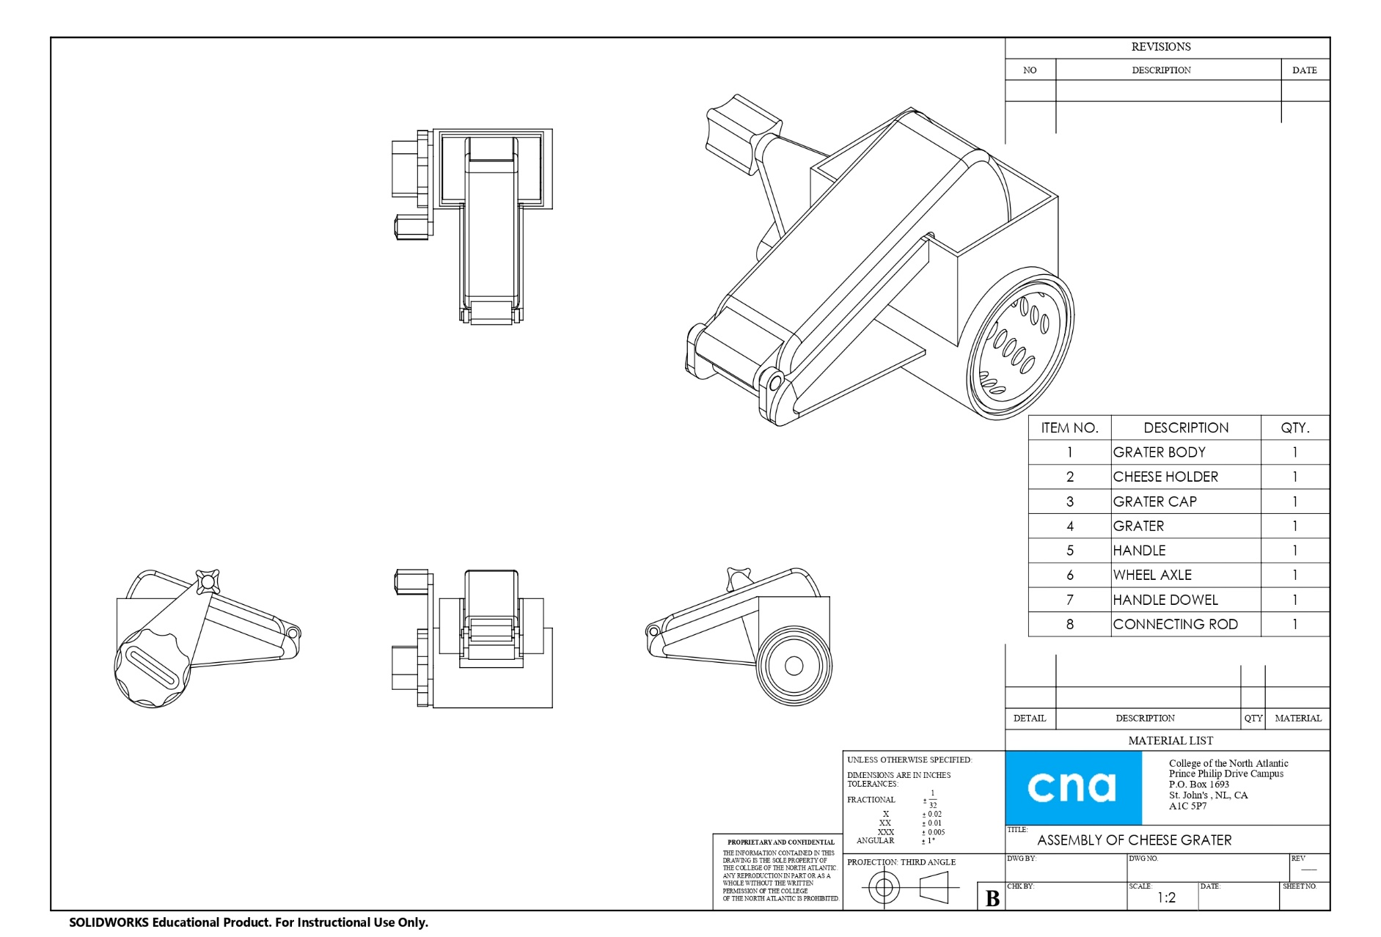

Appendix C

EXPLODED ASSEMBLY DRAWING WITH BILL OF MATERIALS
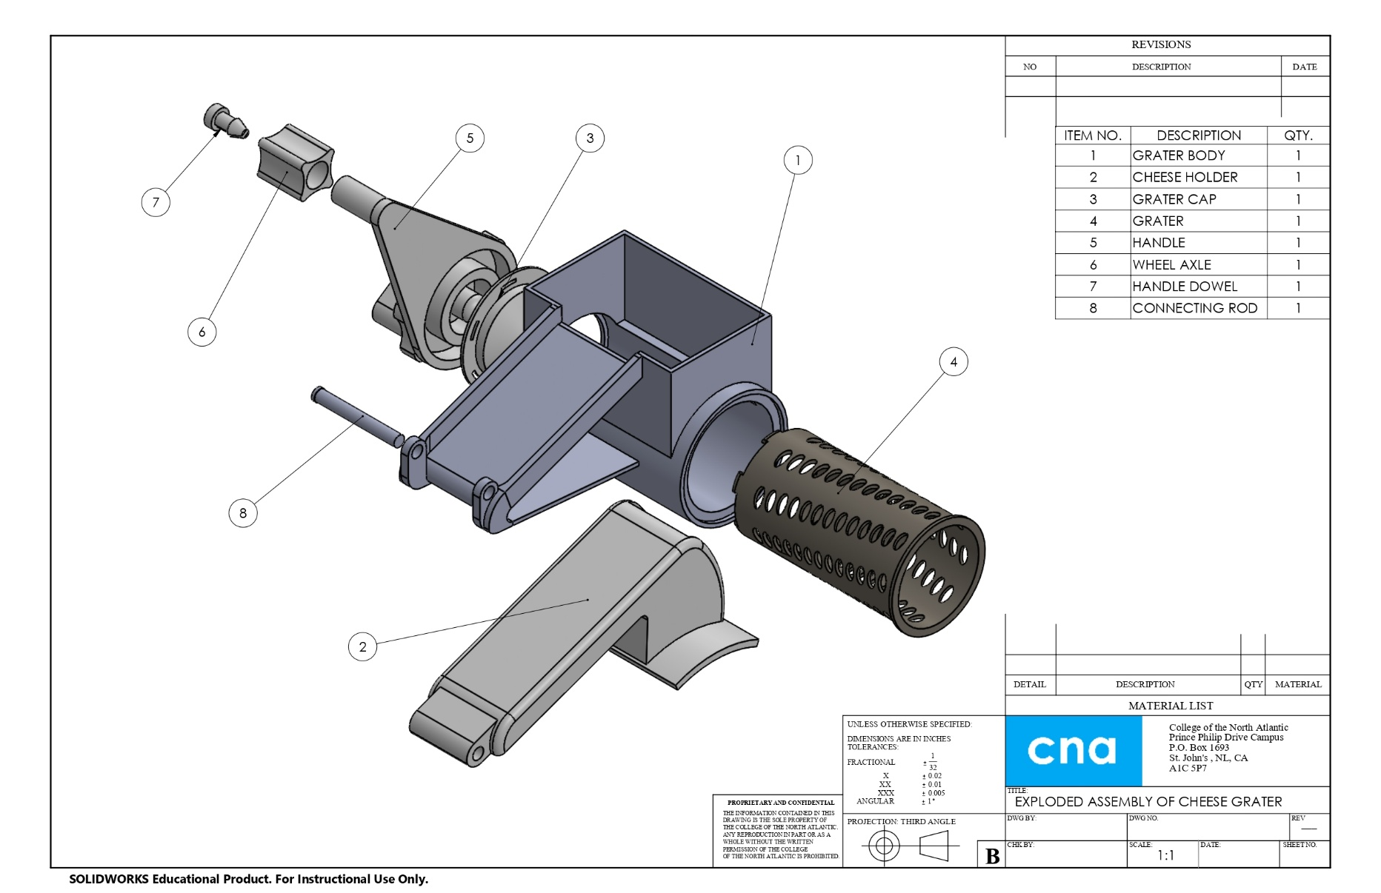

Appendix D

SCREEN CAPTURE OF PARTS AND ASSEMBLY

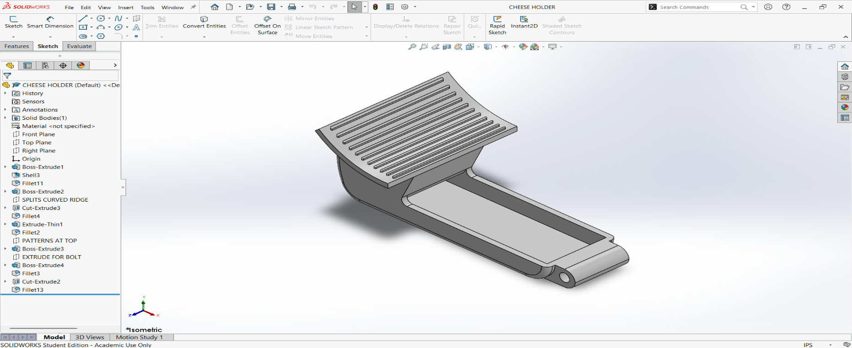  CHEESE HOLDER | 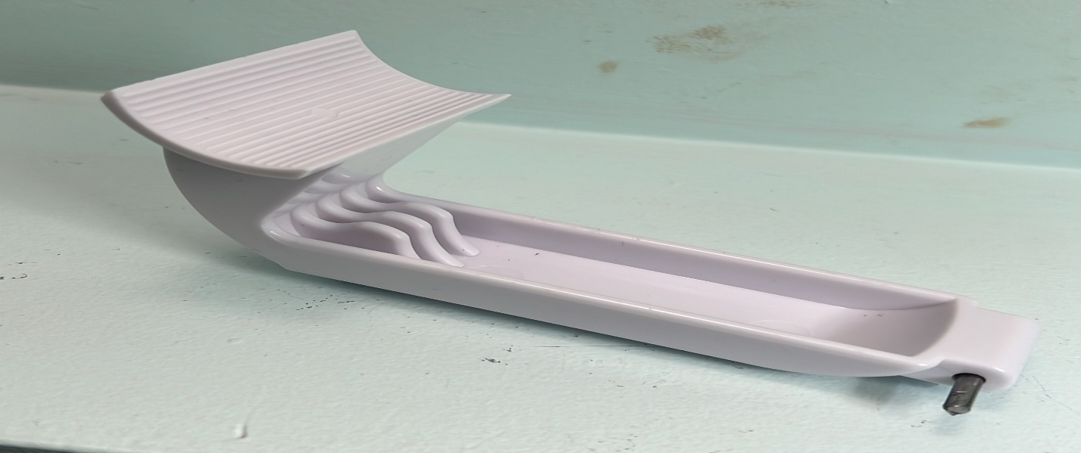
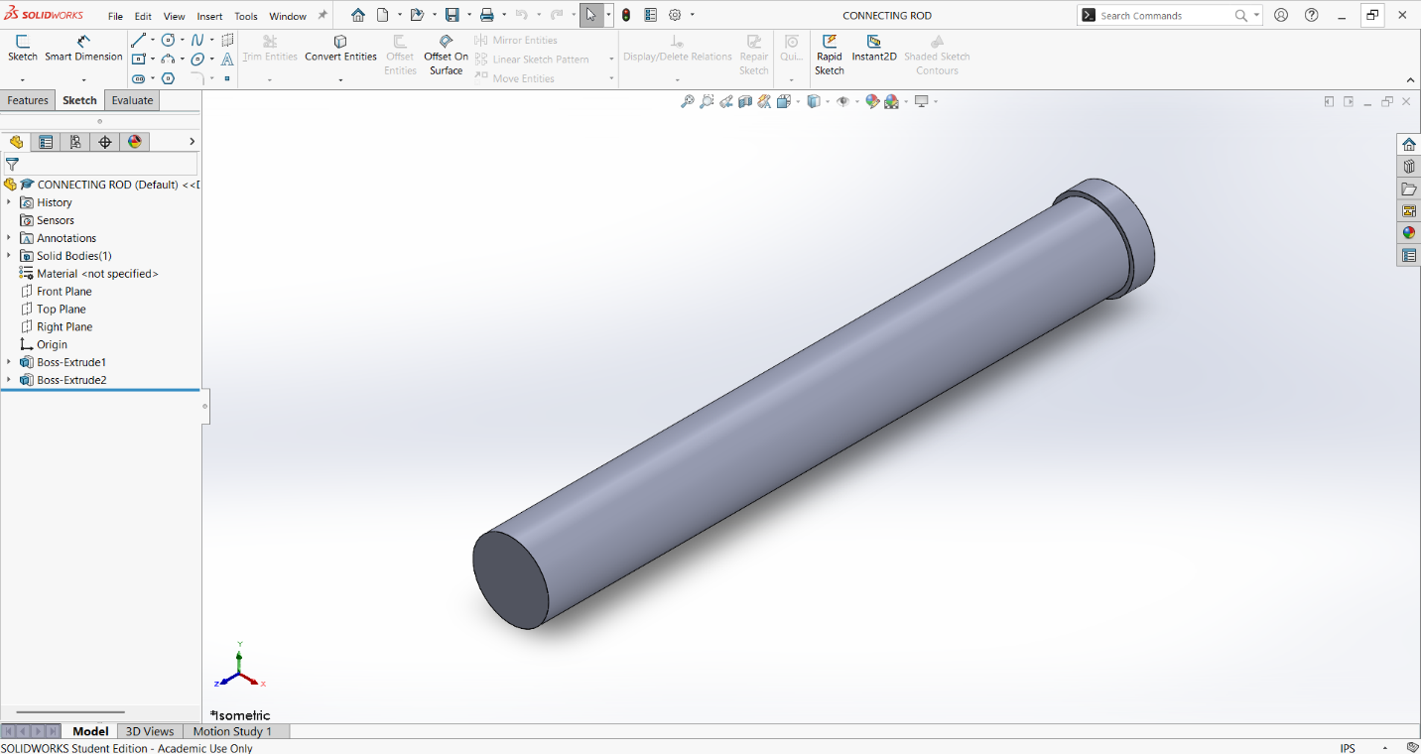
CONNECTING ROD
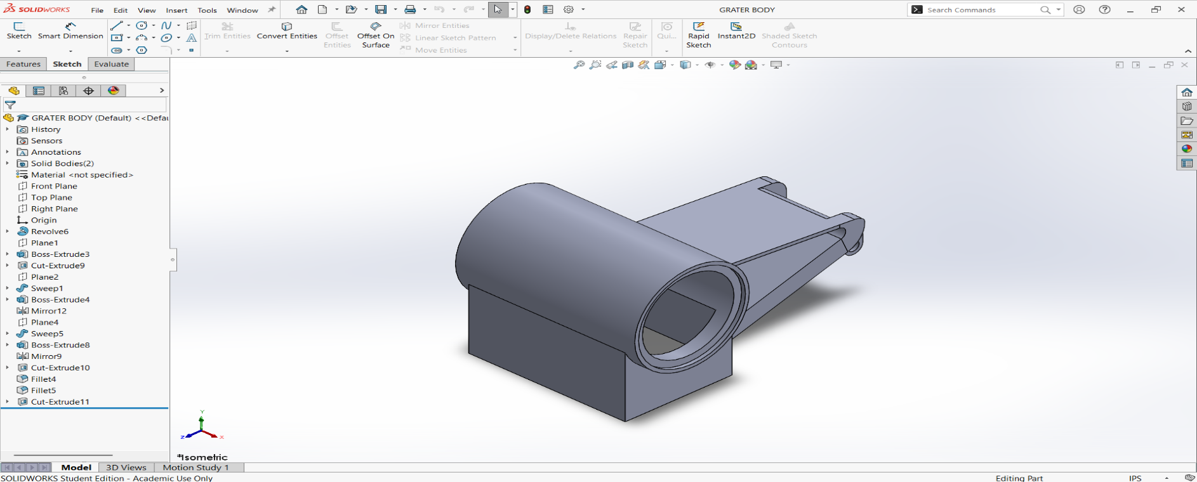  GRATER BODY | 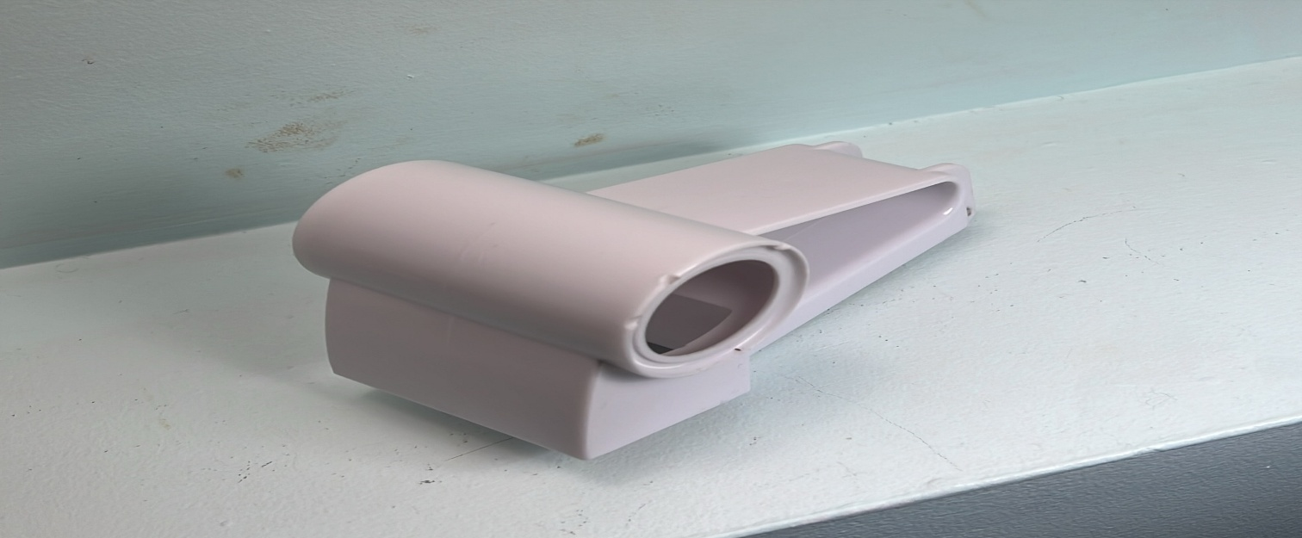
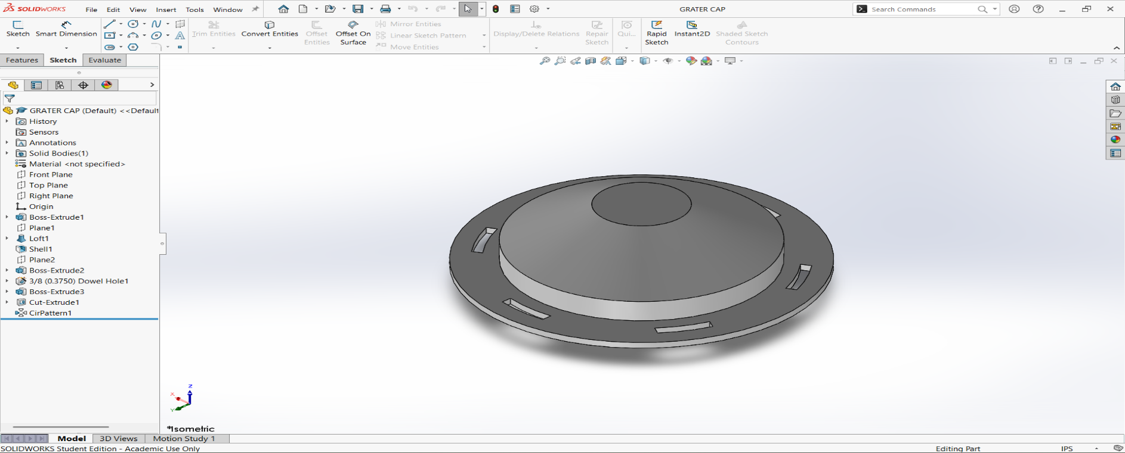 | 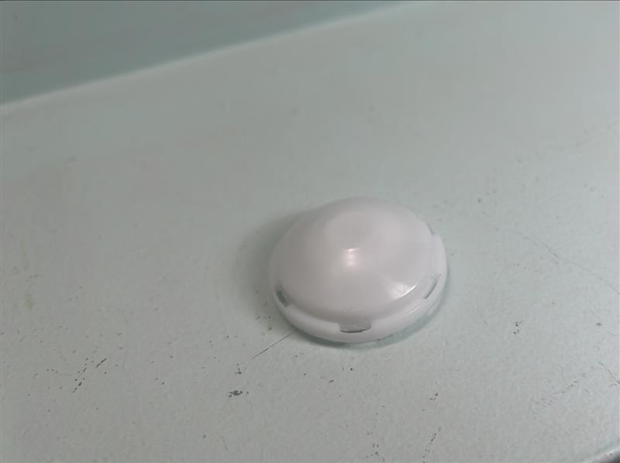  GRATER CAP
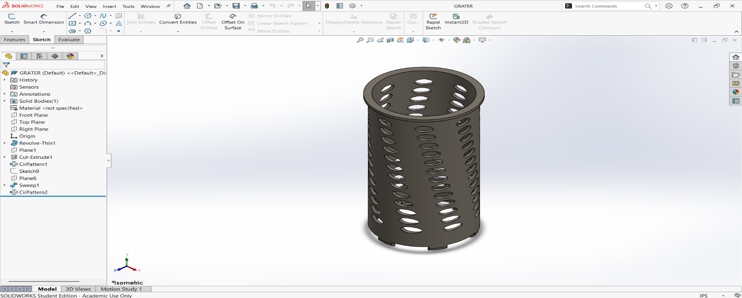  GRATER | 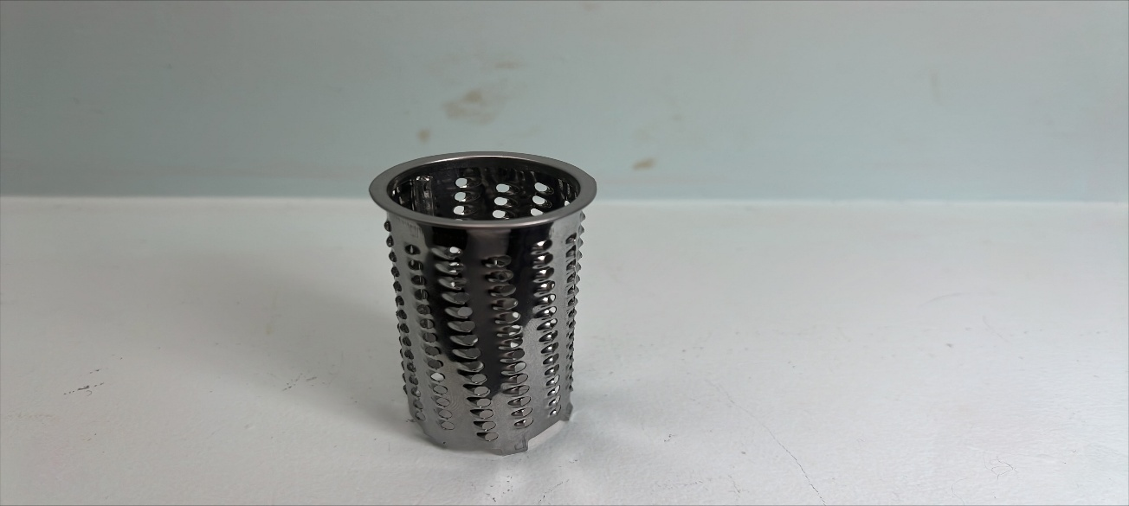
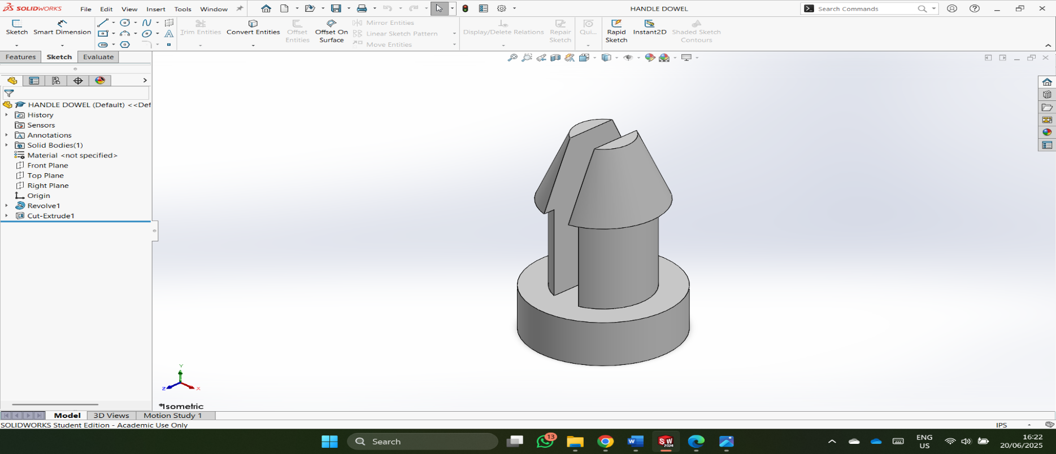 | 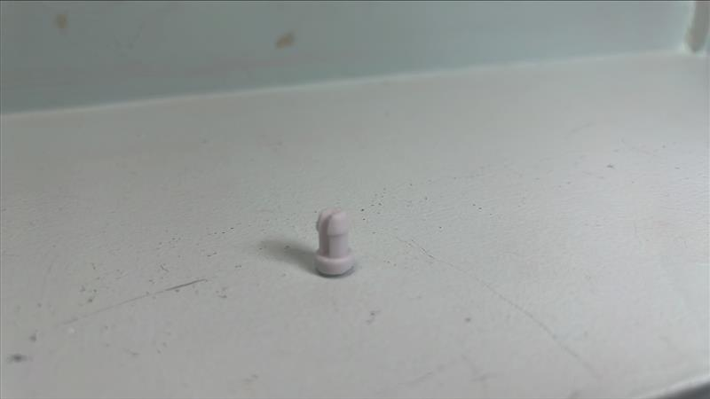  HANDLE DOWEL
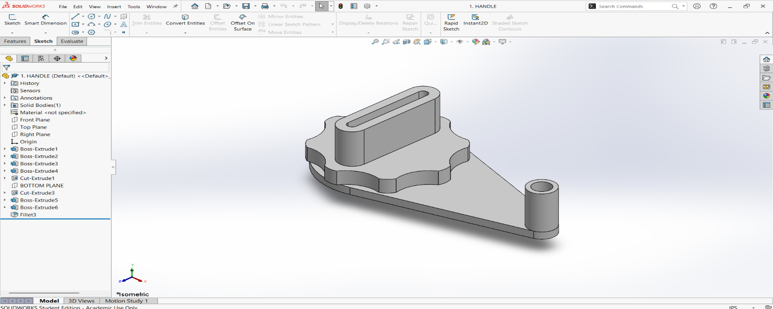  HANDLE | 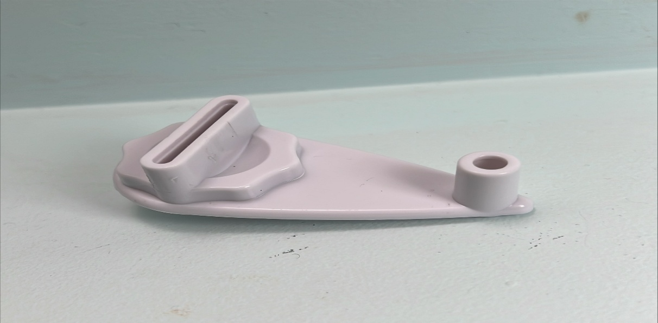
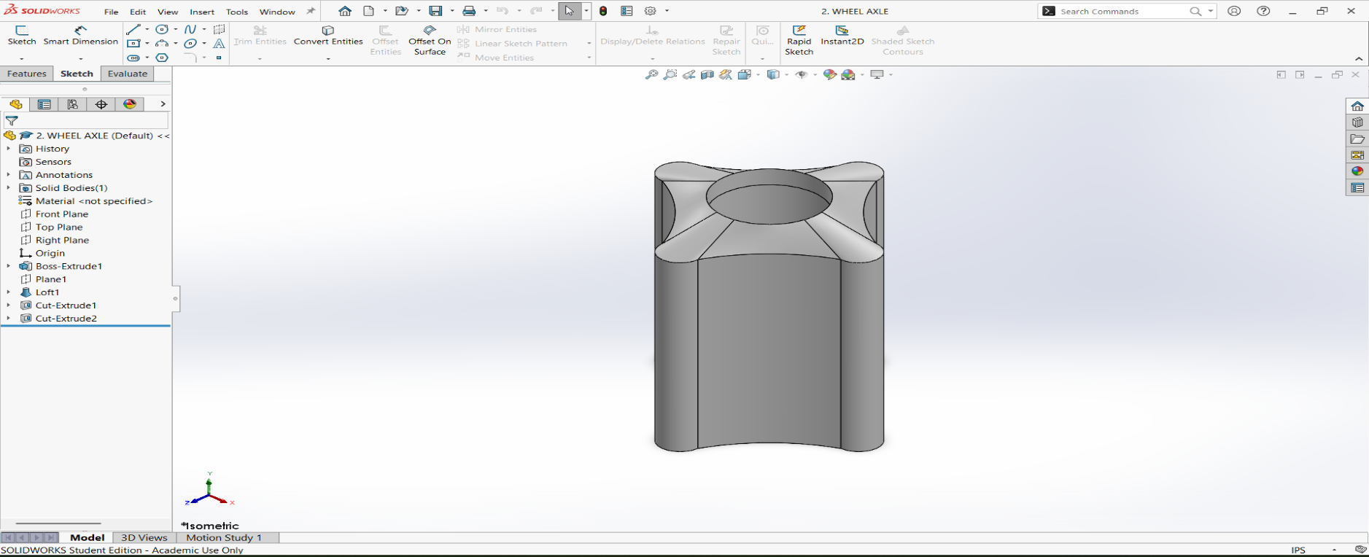 | 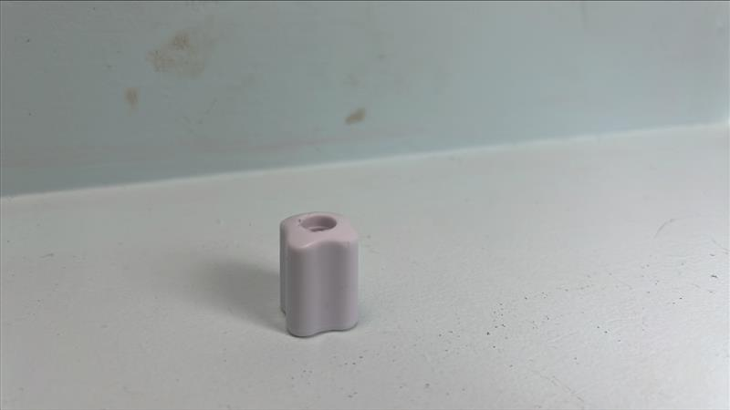
HANDLE DOWEL

Appendix E

HAND SKETCHES WITH MEASUREMENT

